Vertical Redundancy Check (VRC)

1. Also known as parity check.
2. 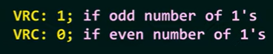
3. 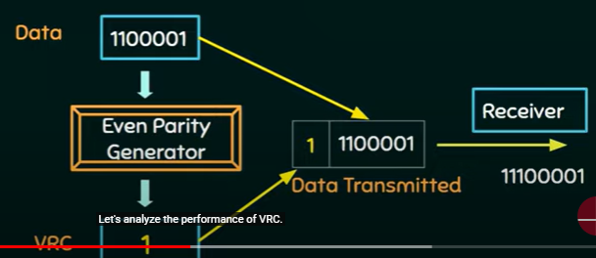

Performance of VRC

1. It can detect single bit error
2. It can detect burst error only if the number of errors is odd.